LOAD TAGS DOCUMENTATION

ADVANTZWARE DATA

The menu O-U-7 dumps data into a text file that the label software reads to print a label.
N-K-1 Loadtag character value lists the bar code software used which dictates the text file format that is downloaded. Most clients set this to SSLabel which is short for Sharp Shooter Label Matrix.

N-K-1 BarDir Description Field: Stores the folder / directory for storing the text file that is used with the label matrix or bar code anything software including finished goods load tags, work in process tags and raw material tags are stored as text files under the directory (folder) as defined by the description. There must be a folder (directory) on the machine that stores the Label Matrix software, labels and text file for Advantzware data. Single user licenses are normally loaded on the disk drive C:\BA\LABEL. Labels will be created from the machine that label matrix is loaded on.

Advantzware creates a text file and passes it to a text file. The text file is determined based on the N-K-1 BarDir integer value. If the value is 0, then the text file is pulled from the control parameter N-K-1 BarDir via the disk drive directory defined on the description field. Most clients name this BA \ LABEL. The label matrix forms most often also reside in this directory.

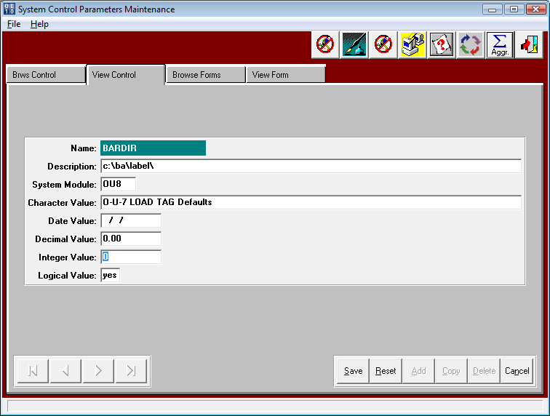

LOAD TAGS

ADVANTZWARE DATA for MULTI USER LICENSE

Label Matrix also has a server based product which would allow all users to point to one copy of this label generation software and share labels. Sharp Shooter computer users such as forklift mounted computers or handheld devices may connect to the server via terminal services communications. Under this scenario, all the users will not want to share the same text file.
The V10 users file under menu N-U has a field called Pallet Load Tag / Case Label Text File Path. Each user must define a unique text file location that has been created on the network server. Once updated, the user will create labels specific to their orders without unwanted merging with other users.

Advantzware creates a text file and passes it to a text file. The text file is determined based on the N-K-1 BarDir integer value. If the value is 1, then the text file is pulled from the user file, therefore the Advantzware data will be transferred to the users text file when printing a loadtag label. If the user file is blank, then the logic work as if the integer value is 0 as explained above.

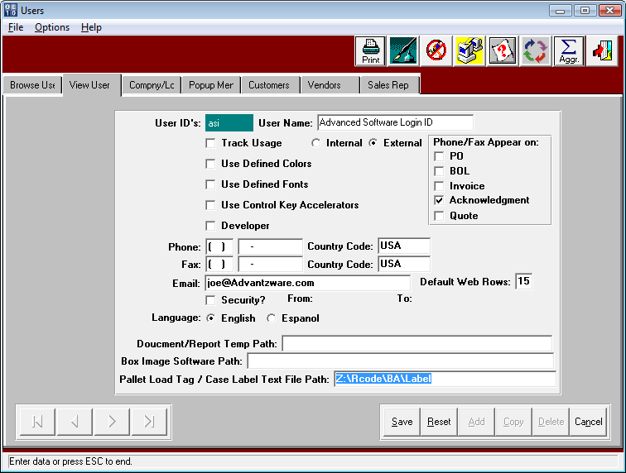

LOAD TAGS

STORING SPECIFIC LOAD TAGS TO PRINT

The control parameters N-K-1 BarDir and N-K-1 LoadTag dictate all the unique printing logic for printing pallet tags via the menu options O-U-7 or the Loadtag Icon on the Item folder of O-U-1.
N-K-1 BarDir Logical Value = YES will turn on logic to print LOADTAGS per item or customer.
LoadTag Label will transfer to the O-U-7 field based on the following hierarchy.

A) Finished Goods Item File - Total/CP# Folder
B) N-K-1 BarDir View Form by Shipto when A is blank
C) N-K-1 BarDir View Form by Customer when A & B are Blank

The finished goods item file can store a specific pallet tag by item under the Totals/CP# tab.
An F1 on this field provides a search of the disk drives to find the proper label.
Below, I have defined the Z:\BARCODE LABELS\LABEL MATRIX\loadtag.qdf

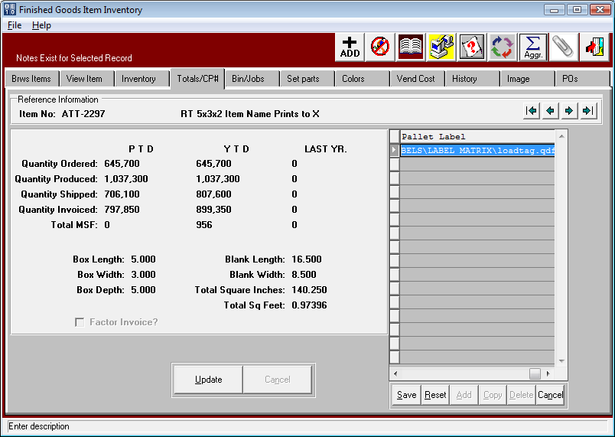

When Printing the Load Tag, once a order # is entered, the program will display all items.
This will also display the LOADTAG LABEL based on the hierarchy noted above.
If a unique Load Tag label exists for an items customer part number, this form will display. If the item does not have a unique Loadtag label, then the label by customers shipto location will print. Next, the program will search for a unique label by the customer. Finally, if there are not unique labels defined, the program will allow the end user to pick a label from the Bar Code Software Program. Please note, any label the display on the O-U-7 print screen may be changed before printing. A new toggle box called AUTOPRINT will automatically launch Label Matrix and print the selected file with the printing the Load Tag.
LOAD TAGS

STORING SPECIFIC LOAD TAGS TO PRINT

N-K-1 BarDir Logical Value = YES hierarchy.

A) Finished Goods Item File - Total/CP# Folder
B) N-K-1 BarDir View Form by Shipto when A is blank
C) N-K-1 BarDir View Form by Customer when A & B are Blank

If the label is blank in the Totals/CP# tab for the finished goods item, then the system looks for a unique tag by Customer Ship To location as defined in the View Forms tab.

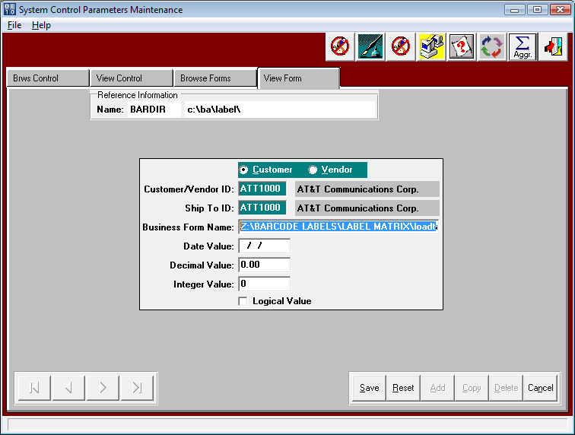

When Printing the Load Tag, once a order # is entered, the program will display all items.
This will also display the LOADTAG LABEL based on the hierarchy noted above.
If a unique Load Tag label exists for an items customer part number, this form will display. If the item does not have a unique Loadtag label, then the label by customers shipto location will print. Next, the program will search for a unique label by the customer. Finally, if there are not unique labels defined, the program will allow the end user to pick a label from the Bar Code Software Program. Please note, any label the display on the O-U-7 print screen may be changed before printing. A new toggle box called AUTOPRINT will automatically launch Label Matrix and print the selected file with the printing the Load Tag.

LOAD TAGS

STORING SPECIFIC LOAD TAGS TO PRINT

N-K-1 BarDir Logical Value = YES hierarchy.

A) Finished Goods Item File - Total/CP# Folder
B) N-K-1 BarDir View Form by Shipto when A is blank
C) N-K-1 BarDir View Form by Customer when A & B are Blank

If options A and B are above are blank then the program will search for a unique pallet tag for the customer code only. As you can see below, only the customer code is defined.
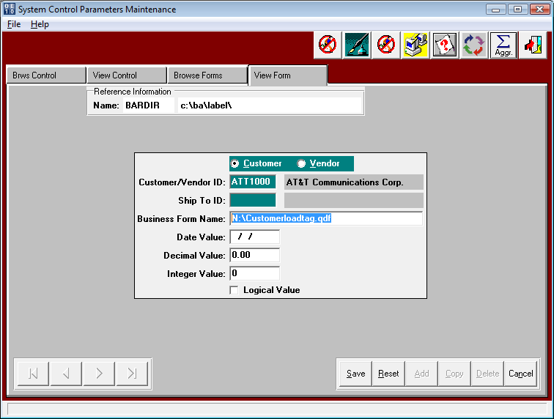

When Printing the Load Tag, once a order # is entered, the program will display all items.
This will also display the LOADTAG LABEL based on the hierarchy noted above.
If a unique Load Tag label exists for an items customer part number, this form will display. If the item does not have a unique Loadtag label, then the label by customers ship to location will print. Next, the program will search for a unique label by the customer. Finally, if there are not unique labels defined, the program will allow the end user to pick a label from the Bar Code Software Program. Please note, any label the display on the O-U-7 print screen may be changed before printing. A new toggle box called AUTOPRINT will automatically launch Label Matrix and print the selected file with the printing the Load Tag.

Printing LOAD TAGS

PRINTING LOAD TAGS

O-U-1 has an Icon shown below. This same screen is available via OU7 (load Tag creation).
The load tag creation screen provides many options to select what fields are downloaded to the text file. The number of duplicate tags to print is dictated by the customer file field called No of Load Tags. This allows up to four load tags per pallet. Each tag will have the same tag number for scanning however it is duplicated based on this field. If this is blank, the program will search the integer value defined on the N-K-1 Loadtag parameter.

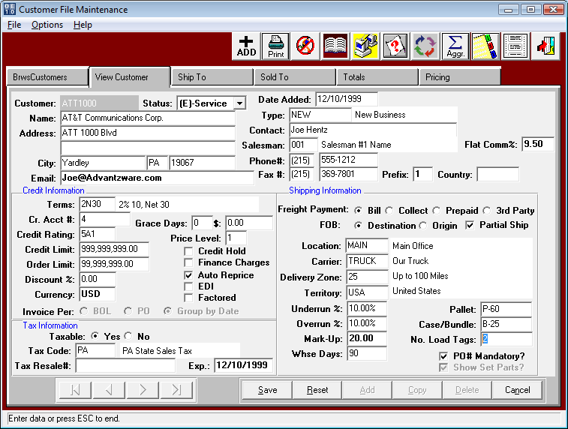

Printing LOAD TAGS

Then total number of load tags to print is dictated by the N-K LoadTag Decimal Value.
Decimal Value = 0 will generate just 1 unique load tag. This option would be used when producing load tag for each pallet produced on the production floor. The N-K-Caselabel value will allow scanning a bar coded case lable to automatically preload the loadtag criteria.
Decimal Value = ? will default the number of load tags to 0 so that the number of tags to be created must be manually entered.
Decimal Value = 1 will to generate the total load tags required by dividing the order quantity by the pallet count. This option is used when printing in the office before actual production. Since the actual quantity produced is unknown at this time, the ASI version will create one additional tag that will have a blank unit count. When receipts are scanned via sharp shooter, the program will prompt for a unit count for this load tag. When printing just 1 tag at a time, the user normally will set the logical value to Yes to prompt for a case label bar code.

N-K Loadtag Logical value = YES will prompt to scan a Case Tag Label to print a Load Tag and bypass the existing load tag print selection menu. The case label must created by the O-U-10 program with the ASI format. Once the case label is scanned, the fields on the normal LOADTAG screen will be automatically populated with the job number, order number and finished goods item number as beginning and ending numbers. This normal print selection menu will be bypassed and then the screen will import the case tag fields to update the quantity per unit/case, units/cases per pallet and partial unit/case. Once SAVED, the system will download the data and the warehouse person can print the LOAD TAG label via the Label Matrix software.

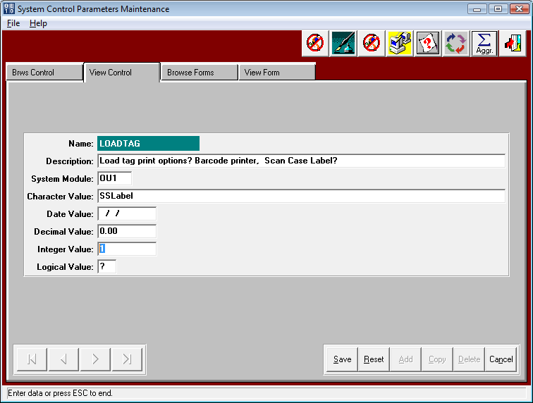.

Printing LOAD TAGS

PRINTING LOAD TAGS

O-U-1 has an Icon shown below. This same screen is available via OU7 (load Tag creation).
The load tag creation screen provides many options to select what fields are downloaded to the text file. The number of tags to print is dictated by the customer file field called No of Load Tags. This allows up to four load tags per pallet. Each tag will have the same tag number for scanning however it is duplicated based on this field. If this is blank, the program will search the integer value defined on the N-K-1 Loadtag parameter.

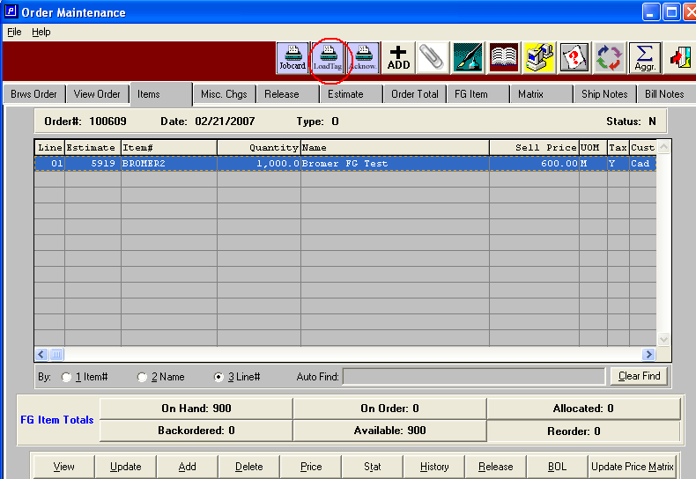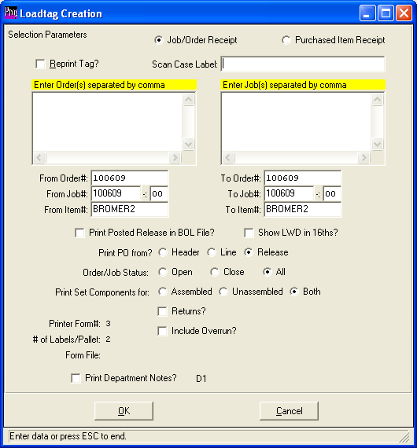

Printing LOAD TAGS

PRINTING LOAD TAGS

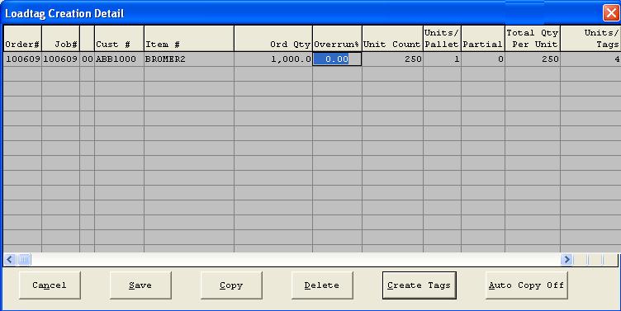

Once you hit the “Create Tags” button (above screen) the text file is sent to the BA/LABEL directory.

When you run Label Matrix you will be able to select the label format (once you used one it is displayed in the “Open recently used label” area).

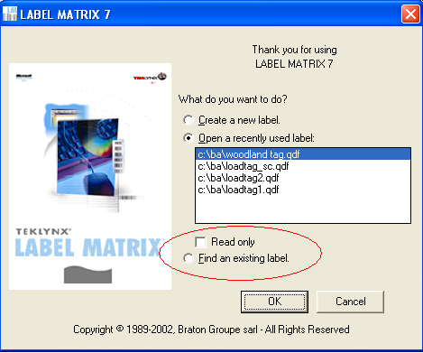

When you select a label format a sample of it is displayed. The “grid” icon on the top of the screen will allow you to display the file of load tag data that was created in Advantzware. You then can use the printer icon, (or the menu option File/ Print) to print the tags.
You can also modify tags and save a custom one to use for your plant.
